Association of Traumatic Stress Specialists
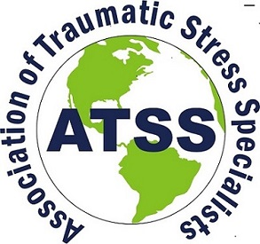
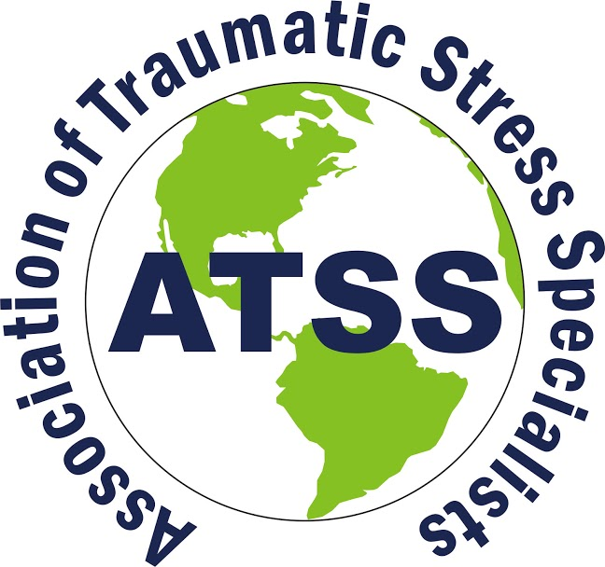
Recognizing standards of excellence in response, treatment and services
www.atss.info

Join the Association of Traumatic Stress Specialists. Gain knowledge, information, networking opportunities and recognition!
Traumatic events such as natural disasters, terrorism, global conflict, violent victimization, and sudden unnatural loss have affected individuals in all communities. The Association of Traumatic Stress Specialists is a diverse international professional organization dedicated to excellence in services and support to individuals impacted by these events and others. ATSS provides professional recognition through international trauma certification to individuals engaged in trauma treatment, services and response, and provides and promotes opportunities for training and education in the field of traumatic stress.

ATSS certification matters because
- Victims, survivors, the general public, and allied professions expect knowledge, experience and protection from harm;
- Certification offers increased value to employers and the community through measured expertise;
- Certification offers increased credibility to practitioners and organizations;
- Organizations and program funders expect and require basic levels of service, accountability and continuing education; and
- Certification is concrete documentation and recognition for your work, skills and experience that stays with you wherever you work or live.

ATSS individual and team member benefits
- Networking - access to an online membership directory of other professionals engaged in treatment, response and services, and access to trauma-specific resources and educational programs and services.
- Professional recognition - eligibility to apply for any of our internationally recognized certifications individuals engaged in services (Certified Trauma Services Specialist/CTSS); response (Certified Trauma Responder/CTR); and/or treatment (Certified Trauma Treatment Specialist/CTTS);
- Mentoring and volunteer opportunities;
- Reduced membership and certification rates for sponsoring new certification applicants or for recruiting new members;
- Professional development – learn about opportunities to participate in and attend international traumatic stress focused conferences and educational events, and have access to free online courses approved for certification;
- Agency, organization or team memberships enjoy individual member benefits and reduced conference and certification fees for five (5) individuals that can include interns and/or volunteers. A great recognition for the staff of your organization!
ATSS MEMBERSHIP INFORMATION

Your name: __________________________________________________ ______________________________________________________

Address: _______________________________________________________________________________________________________
City: ________________________________________________ State/Province:____________________________________________
Country: _____________________________________________ Postal Code: _____________________________________________
Mobile: ___________________________ Office____________________________ Home: _______________________________
Email ________________________________________________________Date:______________________________________________
Do you want this information to be listed in the online membership directory located on our website: www. atss.info Yes No
Please check all that apply. Checks payable in US funds only.
You may also join ATSS and pay by credit card on our website: www.atss.info/membership.
Type of Membership | 1 YEAR | 2 YEAR | Total
Individual | 85.00 | 160.00 | $______.00
Student | 45.00 | 90.00 | $______.00
Senior (65+) | 45.00 | 90.00 | $______.00
Agency/Team for 5 Members | 325.00 | 625.00 | $______.00

ATSS 5052 Old Buncombe Road, Suite 1-11, Greenville, South Carolina, USA 29617
Phone: 864.294.4337 Website: www.atss.info Email: admin@atss.info
Jayne Crisp, CTTS, Administrator

