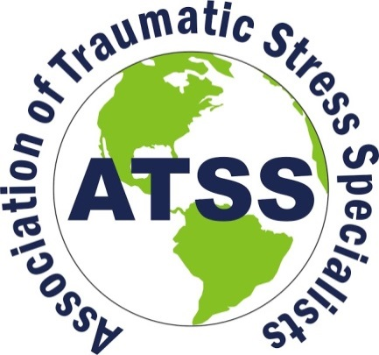
For internal use only

Date received by ATSS;

Date sent to Board:
Board member:
Date of review response:

Certified Trauma Responder (CTR)
Re-Certification Application

Please print legibly or type your name as you would like it to appear on your CTR certificate.

€Contact information:____________________________________________________________________________
First Middle Last

Membership number:__________________________ Certification number:________________________

€Preferred address:_________________________________________________________________________________

€City:______________________________________________€State/Province:_________________________

€Postal Code:__________________________________ €Country:___________________________________

€Website:_______________________________________________ ___________________________________________

€Preferred
e-mail:____________________________________________________________________________________
€Additional
e-mail: _______________________________________________________________________________________

€Preferred phone: Mobile/Home/Business (circle one)____________________________________________________________________________________

€Additional phone #:_________________________________________________________________________
Mobile/Home/Business?
Application Instructions

- Online directory information: Part of your membership will include the opportunity to promote your area of expertise and your services. Would you like the information provided on the previous page included in the online Membership Directory on our ATSS website? Yes No If “yes”, please check the box next to the information on the previous page, that you would like included in the online directory.

- Current ATSS membership documentation. Please attach a copy of payment receipt or Membership Letter. You may pay online at: www.atss.info/membership

- Payment of re-certification fee. Please attach a copy of the payment receipt or acknowledgement email. $175 Re-certification fee (non-refundable) or $75 for seniors and students. You may pay your certification fee online on our ATSS website https://www.atss.info/index.php/certification or by check. If paying by check, please include payment in US Funds only with the completed application and required documentation.

- Copy of current resume (Limit to 6 pages maximum).

Training and education information.

If your certification expires within the next six months, submit 30 hours of continuing education in trauma-related training either online or in person course-work. If your certification expired within the last year, submit 30 hours of continuing education in trauma-related training plus an additional 5 hours for every 6 months past your re-certification date.

- A minimum of 15 hours of attendance must be in continuing education. A certificate of attendance or letter verifying your attendance must accompany your re-certification application for review.
- Up to 10 hours of experience doing the work can be used as part of the 30 hour requirement. For example, a CISM Team Leader can verify that you have completed at least 10 hours of critical incident response work. A letter from your Team Leader/Coordinator/Board member must be included with this renewal application stating that you have completed at least 10 hours of response work.
- Ten (10) hours maximum of training presented by you may be applied toward the 30 hours. A letter or brochure regarding this training can verify ten hours of training
- If you have sponsored a colleague’s ATSS certification application ATSS, 5 hours for each application can be counted toward re-certification. Please include the name and address of those whom you have sponsored. (Maximum of 15 hours).
- Articles written by you relating to traumatic stress services, response, and or treatment may be counted toward a maximum of 5 hours continuing education.

- Name______________________________________________Date_________________(5 hours)

- Name______________________________________________Date_________________(5 hours)

- Name______________________________________________Date_________________(5 hours)
Documentation of Training and Education
Please include documentation of attendance to all the listed training including your own presentations. Include certificates of attendance and/or other valid documentation of attendance. Remember, these hours must be specific to trauma topics or related to traumatic stress issues.

Date Training Provider Workshop title Hours

PLEASE READ CAREFULLY

Preparing Your Application.
In order to expedite the review of our applications, we scan and e-mail the applications to our Certification Board. Your application will be returned to you if you do not follow these instructions!

- Do not make two-sided copies.
- Do not use paper clips or staples.
- Do not send us duplicates (extra copies) of your application.
- Do not attach more than 6 pages of a resume or vitae.
- Do not attach any documentation that is not specifically requested in the application. Or pad the application with additional documentation.
- You may scan the entire document as a PDF and send the entire document as an attachment to an e-mail. However, do not send us e-mails with each page as a separate attachment.
- Make sure your ATSS membership is current!
- Enclose documentation of your recertification payment.

Mail or scan your application with all documentation to:
Association of Traumatic Stress Specialists
5000 Old Buncombe Road Greenville, South Carolina 29617 USA
Attention: Jayne Crisp, CTS, ATSS Administrator
admin@atss.info

